

*Exor Corporation Limited*

*The Global Leader in*

*Infrastructure Asset Management*



*Document Manager*

*System Admin v4.3*



# 

This page intentionally blank

Quality Assurance Statement

|  |  |
| --- | --- |
| **Document Details** | |
| **File:**  Document Manager System Admin v4.3.pdf | **Prepared by:**  T.C. Stewart & Ian Skinner |
| **Manual Name:**  Document Manager System Admin Guide | **Reviewed by:** |
| **Version:**  3.0 | **Approved for issue by:**  T.C. Stewart |
| **Date of Issue:**  Nov 2008 | **Product Manager:**  T.C. Stewart |
| **File Name:**  Document Manager System Admin v4.3.pdf | |

|  |  |  |  |  |
| --- | --- | --- | --- | --- |
| **Document Version Control** | | | | |
| **Revision** | **Date** | **By** | **Chapter / Page** | **Description** |
| 3.0 | Nov 2008 | IS | All | Revised for 4.3 release  Bulk Document loader added. |

CONTENTS

Quality Assurance Statement 1

General Information 5

Prerequisites 6

Product / User Options 6

Document Locations and Media Types – DOC0118 7

Document Locations 7

Locations Archives 10

Archives Configuration 10

Media Types Tab 12

Locations 13

Document Location Configuration 14

Database Table Location Type 14

Database Server Location Type 16

Oracle Directory Location Type 16

Application Server Location Type 16

Template Configuration 17

Document Types / Classes / Enquiry Types - DOC0110 18

Document Types 19

Class 21

Type 22

Document Gateways - DOC0130 23

Documents - DOC0100 24

Documents 24

Associated Records Button 27

Keywords Button 28

Spatial Enablement of Documents 29

Circulation by Person - DOC0114 30

Circulation by Person 30

Document Copies 31

Display 31

Scan/Image… 31

Circulation by Document - DOC0115 32

Circulation by Document 32

Personal Copies 33

Display 33

Scan/Image… 33

Bulk Document Loader – Document Bundles 34

Document Bundles 35

Manage Document Bundles – DOC0310 38

Manage Document Bundles 38

Manage Document Bundles – Process Monitor 39

Manage Document Bundles – Process Execution Log 39

Chapter

1

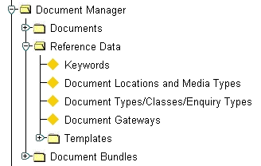Document Manager

Figure 1

Document Manager

Menu

This chapter describes the forms that are used for managing documents held within the ***Exor*** database. They are the following forms:

* Document Locations and Media Types - DOC0118
* Document Types / Classes / Enquiry Types - DOC0110
* Document Gateways - DOC0130
* Documents - DOC0100
* Circulation by Person - DOC0114
* Circulation by Document - DOC0115

The form description provides you with detailed information about the Document Manager forms in ***Exor***, including:

* an overall description of the form.
* a detailed explanation of each field, including available features (such as List of Values), default values and other characteristics.
* Helpful information for using the form.

General Information

***Document Manager by Exor*** allows for the definition, storage, management and retrieval of documents of any media type (e.g. CAD photographs, video). It provides a simple and user-friendly method of integrating multi-media into user applications. Document Manager also allows the user to extend the current reporting features within ***Exor*** by providing user configurable templates for use in Microsoft Word.

***Document Manager*** integrates with all the other modules in the ***Exor*** product set allowing the user to associate documents with any information in the database. Itcan also be used in conjunction with any Oracle based application and, because of its open design, can use any image management or Geographical Information System to store pictures or graphic representations. ***Document Manager***provides a simple, cost-effective entry-level document management system.

Within ***Document Manager*** the user is free to define document types in a flexible manner that allows the system to change over time in line with user requirements. Once defined, documents may be associated with multiple database objects for efficient management of information. For example the same scanned photograph could be stored against a section of the network and an Asset Item in ***Asset Manager*,** as well as against defects in ***Maintenance Manager by Exor***. Also video footage could be associated with a span of a bridge in ***structures manager by Exor*** that also has links to scanned construction drawings, inspectors' comments and scanned photographs. In addition ***Document Manager*** can be used very effectively with ***Enquiry Manager by Exor*** for the storage of letters providing for the efficient monitoring of public complaints.

***Document Manager***  also enables users to create and define their own report templates, using Microsoft Word. These templates can be used toprint data relating toany object in the ***Exor*** database in a user-defined format. The resulting Word document is automatically linked, as a new document, to the database object for future reference. This facility also allows the user to define a number of different templates against the same database object to cater for varying report styles and operational outputs. Typical uses are the production of standard responses to letters of complaint or enquiry from the public and the production of user-defined works order forms.

***Document Manager*** also provides facilities to track documents through an organisation and to monitor who has responsibility for a given document at a given point in time This feature can be used for quality management processes such as ISO9001.

Prerequisites

The flow diagram below indicates the information that needs to be set up prior to using ***Document Manager.***

**Document Gateways**

**(DOC0130)**

Document Types/Classes

**(DOC0110)**

**Locations &**

**Media Types**

**(DOC0118)**

**Documents**

**(DOC0100)**

**Keywords**

**(DOC0116)**

**Circulation by Person**

**(DOC0114)**

**Circulation by Document**

**(DOC0115)**

# Optional

# Optional

New documents may be created in ***Documents - DOC0100*** or by using the [**Create from New**] button on the ***Document Associations*** Window (see Document Manager User Guide).

Product / User Options

The following user option needs to be set:

**WORKFOLDER** this option needs to be defined to point to a local directory on the client PC. This will be used as a temporary working area for file transfers between client PC and Document Location (WebUtil). Files will persist in these areas and may require clearing out on occasion.

Document Locations and Media Types – DOC0118

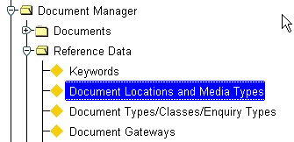Figure 2

Document

Locations and

Media Types

Menu Option

This module is used to specify the different forms of media (scanned photographs, video clips, word documents etc.), the client software needed to display, manipulate or scan the document and where the documents are located on your system.

Each type of media may have more than one location if necessary. For example, this would allow the scanned photographs of bridges to be located in a different location than scanned photographs of defects.

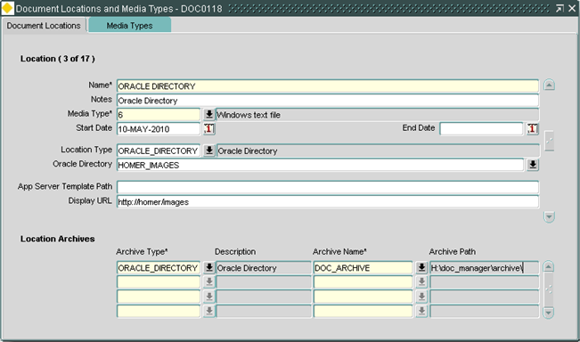Figure 3

Document Locations

Document Locations

When you enter this form the cursor sits in the Name field waiting for you to enter the media name e.g. scanned photos. To display existing data press [**Enter Query**] or press [**F7**], enter your selection criteria, then press [**Execute Query**] or press [**F8**].

Name (Required)

Enter the unique name of the media type.

Notes (Optional)

Enter a description of the document location, for example, Insurance Documents.

Media Type (Required) List

Enter the type of document stored in this location, the media types are defined in the Media Types tab (Figure 8).

Start Date (Optional)

Enter a start date for the document location

End Date (Optional)

To stop using this location enter an end date

Location Type (Required) List

Enter a location type, this may be one of the following:

* Application Server
* Database Server
* Oracle Directory
* Database Table

Location Field (Required) List

Depending on the Document Location Type this label will change to reflect the area which the Documents are to be stored, i.e. “Oracle Directory”, “Table Name” etc. Details are shown below:

Fields on the form change accordingly when choosing Location Type –

**Application Server**

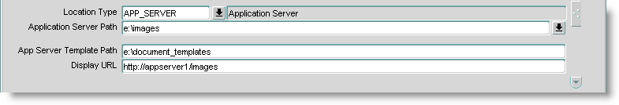**Figure 4**

**Application**

**Server Location**

Application Server locations are locations which are based on the Forms Server.

A MS Word Document template can be used to generate these documents (where appropriate) and this path must exist on the Application Server.

The document location can be made available via a URL (web alias) in the Display URL field.

**Database Server**

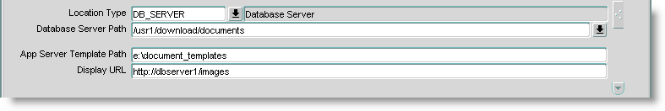Figure 5

Database Server

Location

Database Server locations are locations which are based on the Database Server.

A MS Word Document template can be used to generate these documents (where appropriate) and this path must exist on the Application Server.

The document location can be made available via a URL (web alias) in the Display URL field.

**Oracle Directory**

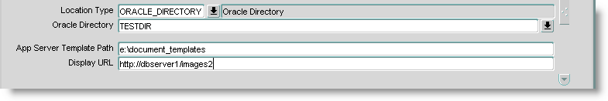Figure 6

**Oracle Directory**

**Location**

Oracle Directory locations are locations which are based on an Oracle Directory. The Oracle Directory must exist as a Hig Directory. Oracle Directories can be configured to point to a file location on the Database Server, or to any Server on the network which the Database Server has full read/write/delete access to.

A MS Word Document template can be used to generate these documents (where appropriate) and this path must exist on the Application Server. The document location can be made available via a URL (web alias). If the Hig Directory has the URL attribute set, the Display URL field should default to this.

**Database Table**

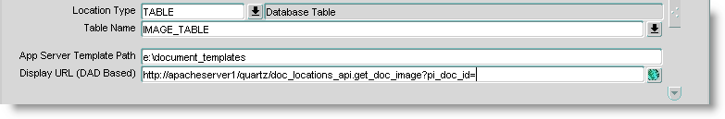Figure 7

**Database Table**

**Location**

Database Table locations are locations which are based on an Oracle Table within the Highways schema. The tables must conform to a certain table column specification which is defined in the ***Document Location Configuration*** section. An existing table can be chosen, or a new table can be created from this Form.

A MS Word Document template can be used to generate these documents (where appropriate) and this path must exist on the Application Server.

The document location can be made available via a URL, however this must be defined using a DAD. Pressing the LOV button will automatically lookup the URL from the NM3WEBHOST system options.

App Server Template Path (Optional) List

If a Document Template File is used (*.DOT) then this path must be set to say where the DOT file is stored.

This ***MUST*** be on the Application Server as this is how Templates are currently generated using OLE in the Oracle Forms.

Display URL (Optional)

If the Document Location is available via a URL, then this is where it the URL is set.

Note, if the Document Location is based on an Oracle Directory, this URL will default to the URL set against the Hig Directories record (if set).

Locations Archives

Archive destination cans be configured. When loading a document into the system using the application, you can define one or more Archive locations where a copy of the document is stored. However, there is no synchronisation between the archives and Document location.

If, for whatever reason, a Location Archive becomes unavailable, the document loading process will carry on without failure but no archiving will take place.

Archive Type (Required)

This is currently restricted to Oracle Directories, a description of the archive type will be displayed in the adjacent field.

Archive Name (Required) List

Enter an existing Oracle Directory name, the Archive path will be displayed in the adjacent field.

Archives Configuration

For each Document Location, you can setup one or more optional Archiving Location. This means that when a Document is loaded either through ***Documents - DOC0100***, ***Document Associations - DOC0120*** or the ***Document Bundle Loader*** a copy of the file loaded will also be placed on the archive location.

If the files in the archives are changed by a 3rd party, at the moment there is no synchronization with the main Document Location and/or other archives.

You can have one or many Location archives defined, these locations must be Oracle Directories.

The archiving process will not stop the load if it fails.

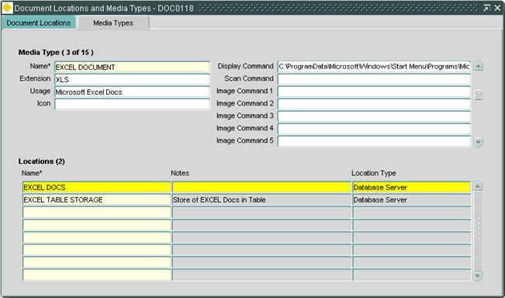Figure 8

Media Types Tab

Media Types Tab

Archive destination cans be configured. When loading a document into the system using the application, you can define one or more Archive locations where a copy of the document is stored. However, there is no synchronisation between the archives and Document location.

If, for whatever reason, a Location Archive becomes unavailable, the document loading process will carry on without failure but no archiving will take place.

Name (Required)

Enter the unique name of the media type.

Extension (Optional)

Enter the file extension e.g..DOC or .GIF for this type of media

This field is used in the File Picker which helps filter the files you are choosing to load from the client.

Usage (Optional)

Enter a description for the media.

Icon (Optional)

Enter the icon name that is to be used for this media type.

Display Command (Optional)

Enter the full hierarchical path of the PC-resident tool you wish to use to display media of this type.

Note that if the environment variable PATH specifies the location of the display tool you do not need to enter the full hierarchical path.

Scan Command (Optional)

Enter the full hierarchical path of the PC-resident tool you wish to use to scan images.

Note that if the environment variable PATH specifies the location of the display tool you do not need to enter the full hierarchical path.

Image Command 1 -5 (Optional)

Enter other operating system commands that may be used for this media type, e.g. for a media type of ASCII you may have an edit command and a print command.

Locations

The information displayed here is read only and shows the document locations used for the associated media type.

Document Location Configuration

This section describes how to configure the different types of document locations specified in the *Document Locations and Media Types – DOC0118*

Database Table Location Type

To setup a Document Location based on type “TABLE – Database Table”, you can either use an existing table, or ***Document Locations and Media Types - DOC0118*** can create one for you.

Existing Table

To use an existing table it must be created to the following standard:

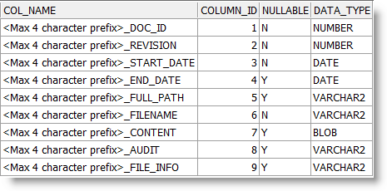

Figure 9

Existing Table

Format

The columns in the table must follow the naming convention:

<Max 4 character prefix>_NAME, for example:

* EXCL_DOC_ID

or

* AN_DOC_ID

When you want to use an existing table, the LOV will return all tables with a BLOB column defined. It, however, does NOT validate the columns on the table for compatibility with this table specification at the time the list is generated.

However, when the Document Location is committed, the table will be validated for compatibility

Create New Table

When you don’t already have a storage table setup, you can use ***Document Locations and Media Types - DOC0118*** to create one for you. Simply enter the name of the table in the ‘Table Name’ field, and fill in the rest of the fields. Upon Commit, the form will display the following confirmation message:

Figure 10

**Create New**

**Table**

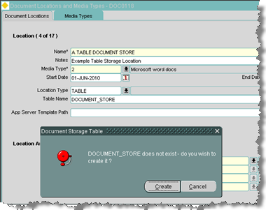

When you click on “Create” you will be prompted the following:

Figure 11

**Document**

**Storage Table**

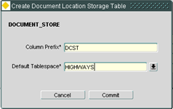

Column Prefix (Required)

Enter a maximum of 4 characters for a column prefix.

Default Tablespace (Required)

Enter the tablespace for the new table. This will default to the same tablespace your User is in.

Press [Commit] to finish the Document Location table creation.

Press [Cancel] to exit.

Database Server Location Type

When setting up a Document Location which points at a Database Server Path, choose ‘DB_SERVER – Database Server’ as a Location Type.

Enter the path to the database server location in the ‘Database Server Path’ field.

Optionally add a Template and URL if applicable.

The database path must be accessible by UTL_FILE_DIR parameter on the database itself.

Oracle Directory Location Type

When setting up a Document Location which points at an Oracle Directory, choose ‘ORACLE_DIRECTORY – Oracle Directory’ as a Location Type.

Enter the name of the Oracle Directory in the ‘Oracle Directory’ field.

This HAS to exist as an HIG_DIRECTORY, as configured in ***Directories - HIG1895***.

Optionally add a Template and URL if applicable. If a URL is set on ***Directories - HIG1895*** in the Miscellaneous tab, it will default here.

The Oracle Directory must be setup to a path on a server for which you have Read/Write access. It is important that access is allowed, otherwise transfers to Document Locations of this nature will encounter problems.

The main advantage of using an Oracle Directory is that you can create one to write away to virtually any machine you have access to on the Network.

Application Server Location Type

There is an option to read and write files directly to the Application Server. This is a fairly restrictive Document Location Type in the sense that it can only really be used via the Forms.

The Document Bundle Loader will ***NOT*** be able to load files into any Document Location defined as ‘APP_SERVER – Application Server Path’

The reason behind this is access, when moving files around using pure PL/SQL routines, you need to have a path available to write to via UTL_FILE_DIR or an Oracle Directory. Some of the later dbms_lob code used only works with Oracle Directories.

Therefore, the best approach is to define the path to the Application Server from the Database Server as an Oracle Directory.

Only WebUtil (the way the Forms move the files around) can easily write to and from the Application Server

Template Configuration

The Microsoft Word Template files must exist on the Application Server due to the OLE technology used in the Forms libraries.

The resultant .DOC files will be moved onto the Document Location upon creation.

The Document Location must be setup with the path to the Template .DOT file as shown below:

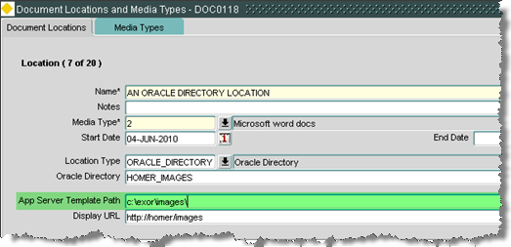

Figure 12

Template

Configuration

This is must be a directory on the Application Server, and must be suffixed with the backslash trailing directory separator ‘\’.

Therefore on the Application Server, the template file must exist in the path shown above:

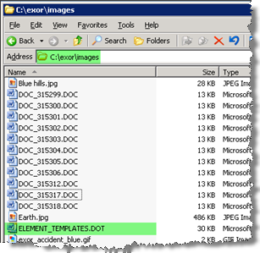

Figure 13

Template

File

The Template file will be written out to the Document Location, i.e. Table or Database Server, and a copy will also optionally be placed into the Archive area.

Document Types / Classes / Enquiry Types - DOC0110

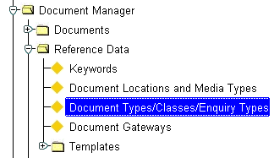Figure 14

Document Types

Menu Option

The ***Document Types/Classes/Enquiry Types – DOC0110*** module is used to define different types of Documents that will be available within the system. A Document Type is a way of identifying documents of a similar nature.

Within ***Enquiry Manager by Exor*** Document Types are used as the Enquiry Category e.g. 'Complaint' or 'Correspondence'. Each of these Enquiry Categories may have many associated Enquiry Classes each with its own Enquiry Types. For example, an Enquiry Category of 'Complaint' may have Enquiry Classes of 'Formal' and 'Informal'. Each of these Classes may be further defined by the Enquiry Type that allows the nature of the Enquiry to be recorded. For example, the Enquiry Class 'Formal', may have Enquiry Types such as 'Pothole', 'Drainage' etc, describing the broad nature of the complaint.

A combination of Enquiry Category, Enquiry Class and Enquiry Type may be used to generate Standard Actions, which must be undertaken, when an Enquiry is logged or amended (see the Enquiry Manager User and System Admin Guides for more information on Standard Actions).

If Defects are raised directly from ***Enquiry Manager*** a combination of the Enquiry Category and Enquiry Type are used to associate the Enquiry with a Defect Type and Treatment. This is done using ***Enquiry/Treatment types - MAI1320***. Product Option **ENQSTODEF** must be set to **‘Y’** to allow Defects to be raised directly from an Enquiry.

A Works Contract may be associated with an Enquiry Type that allows Contract Items and quantities to be added to an Enquiry whenever the appropriate Enquiry Type is selected. This allows costs etc to be calcualted for any Works associated with the Enquiry.

The default Category, Class and Type for a new Enquiry are defined using Product / User Options **ENQCAT**, **ENQCLASS** and **ENQDEFENQT** respectively.

Note that if a document type is to be used within Enquiry Manager the 'Allow Complaint' flag must be set to 'Y'.

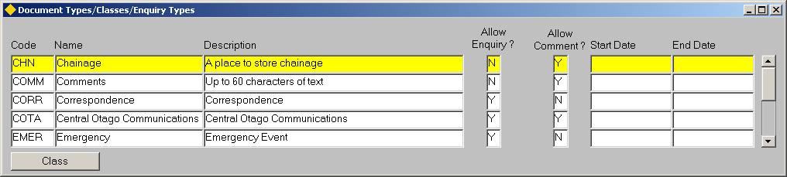Figure 15

Document Types

/ Classes / Enquiry Types

Document Types

When you enter this form all existing Document Types will be automatically displayed. To create a new Document Type press the [**Create Record**] or press [**F6**].

Type Code (Required)

Enter a unique value for the Document/Enquiry Type code. A maximum of 4 characters is allowed.

Type Name (Required)

Enter a value for the Document/Enquiry Type name. A maximum of 30 characters is allowed.

Description (Optional)

Enter the description of the document type.

Allow Enquiry? (Required)

Enter '**Y**' if this Document Type relates to ***Enquiry Manager***. If set to ‘Y’ this Category will be available for selection in the ***Enquiry – DOC0150*** module. Set to **‘N’** for use with Document Manager.

Note that if this field is flagged with a 'Y', this Document Type will not be available when creating a Document using the 'Document' - DOC0100 module but may be selected when creating a Document Association using the [Document] button on the Forms menu toolbar. For further information on Document Manager refer to the Document Manager User and Admin Guides.

Allow Comment? (Required)

Enter '**Y**' if this Document Type relates to the storage of comments. Otherwise enter '**N**'.

Note that if this field is flagged with a 'Y', this Document Type will not be available when creating a document using the 'Document' - DOC0100' form. Document Comments are entered in the ‘Title Field’ of the Document Associations – DOC0120 form called from ‘host modules’ by pressing the [Documents] button on the forms menu toolbar.

Start Date (Optional)

Enter the start date for the Document Type. The Document Type will not be valid before this date and will therefore not appear on any List of values.

End Date (Optional)

Enter the date this Document Type is no longer valid. The Document Type will not be valid after this date and will therefore not appear on any List of values.

To define Enquiry Classes for an Enquiry Category press the [**Class**] button.

Figure 16

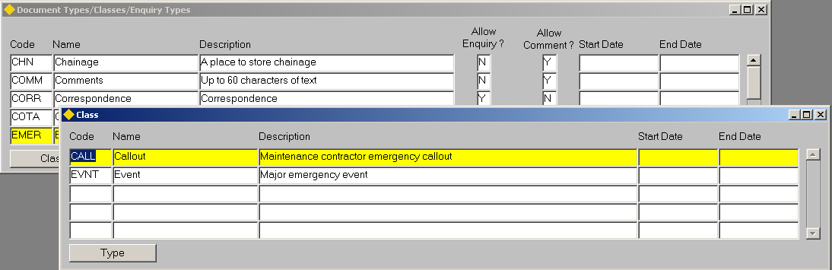Class

Class

This panel is used to create Enquiry Class for the assocaited Enquiry Category. The Enquiry Class is used as a factor for generating Standard Actions and is also used for defining which Enquiries are subject to the conditions imposed under the WOOLF report (dependenton Product Option ENQWLFCLAS)*.*

When you enter this form any Enquiry Classes already created for the selected Enquiry Category will be displayed. To add a new Enquiry Class press the [**Create Record**] button on the toolbar or press the [**F6**] key.

Code (Required)

Enter a code for the Enquiry Class. A maximum of 4 characters is allowed.

Name (Required)

Enter a name for the Enquiry Class. A maximum of 30 characters is allowed.

Description (Optional)

If required enter a description for the Enquiry Class

Start End (Optional)

Enter the start date for the Enquiry Class. The Enquiry Class will not be valid before this date and will therefore not appear on any List of values.

End Date (Optional)

Enter the date this Document Type is no longer valid. The Enquiry Class will not be valid after this date and will therefore not appear on any List of values.

To define Enquiry Types for an Enquiry Class press the [**Types**] button (*page22).*

Figure 17

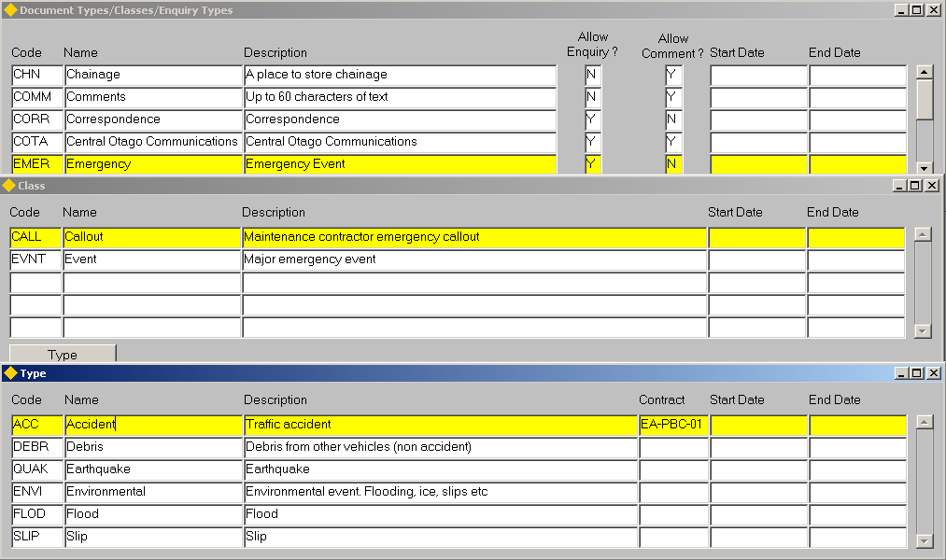Enquiry Types

Type

This panel is used to create Enquiry Types for the assocaited Enquiry Class / Category combination. The Enquiry Type is used as a factor for generating Standard Actions and is also used for associating an Enquiry with a Defect Type and Treatment if defects are raised directly from the Enquiry module.

Note that Enquiry Types can only be created for Document Types which have the 'Allow Complaint' flag set to 'Y'.

Code (Required)

Enter a code for the Enquiry Type. A maximum of 4 characters is allowed.

Name (Required)

Enter a name for the Enquiry Type. A maximum of 30 characters is allowed.

Description (Optional)

If required, enter a description for the Enquiry Type

Contract (Optional)

If required select a Works Contract to associate with the Enquiry Type. Associating a Contract with an Enquiry allows Contract Items and quantities from the Contract to be added an Enquiry using this Category / Class and Type combination. This allows costs etc to be calcualted for any Works associated with the Enquiry.

Start End (Optional)

Enter the start date for the Enquiry Type. The Enquiry Type will not be valid before this date and will therefore not appear on any List of values.

End Date (Optional)

Enter the date this Enquiry Type is no longer valid. The Enquiry Type will not be valid after this date and will therefore not appear on any List of values.

Document Gateways - DOC0130

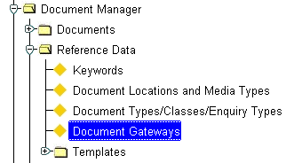Figure 18

Document Gateways

Menu Option

This form is used to maintain the gateways from the document management interface to the records held within the ***Exor*** database.

A comprehensive set of records contained within this table is supplied as meta data when the system is first installed. This form has been provided mainly for use of the ***Exor*** support staff and **SHOULD NOT** be changed by the customer.

Any changes made to records within this table could cause considerable problems when using the document management interface. It is recommended that this form be removed from the menus of all but the most experienced users.

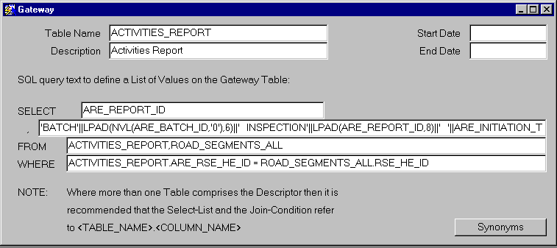Figure 19

Document

Gateways

Documents - DOC0100

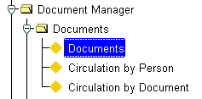Figure 20

Documents

Menu Option

This form is used to record document or image details and keywords or scan images and associate them to records held within the ***Exor*** database.

Documents or images may also be associated with records using the Document Manager interface on any form within ***Exor*** that has access to the ***Document Manager*** facility (see Document Manager User Guide).

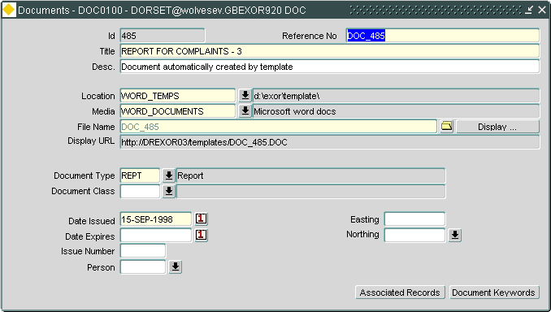Figure 21

Documents

Documents

When you enter this form the cursor sits in the Reference No. field waiting for you to enter new data or retrieve existing data. To display existing information press [**Enter Query**] or press [**F7**], enter your selection criteria then press [**Execute Query**] or press [**F8**].

Id (Display Only)

A unique system generated number will be displayed.

Reference No. (Required)

Enter a value for the document reference.

Title (Required)

Enter the document title.

Description (Optional) (Edit)

Enter a description of the document.

Location (Required) (List)

Enter the operating system location name of the document file. This will have been previously set up using:

***Locations and Media Types - DOC0118*** (Figure 3)

Media (Required, Default) (List)

Enter the format that the file exists in on the system. The default is the media type set up using ***Locations and*** ***Media Types - DOC0118*** (Figure 3),this value may be changed if required.

Filename (Required) (List)

Enter the operating system filename of the document. Double clicking this field will open a windows 'Find File' dialog box (Figure 22 The default 'Look in' folder in the Find File dialog box will be determined by the 'Path' defined for the chosen 'Location' in ***Locations and Media Types - DOC0118*** (Figure 3).

The default file type in the 'Choose file for upload to server' dialog box will be determined by the 'Extension' defined in ***Locations and*** ***Media Types - DOC0118*** (Figure 3).

***Note.When choosing a file to associate with a new document record, you are presented with a File Selection box. This defaults to a directory on the Client Machine determined by the user option WORKFOLDER.***

Note that you should include the DOS extension if the filename includes one.

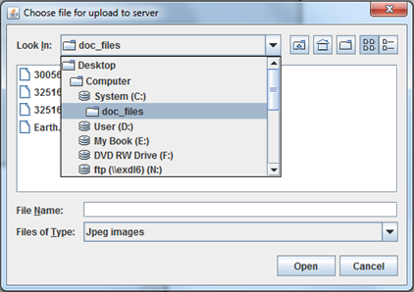

Figure 22

Choose File

When the document is saved, the selected file is uploaded to the Document Location, and optionally Archived.

The **[Display]** button will display the saved document.

Document Type (Required) (List)

Enter a valid code for the Document Type, e.g. PICT, REPT etc. These will have been previously set up using ***Document Types/Classes - DOC0110*** . A description will be displayed in the adjacent field.

Document Class (Optional) (List)

Enter a valid code for the Document Class, e.g. CONF,CINC etc. These will have been set up previously using ***Document Types/ Classes - DOC0110***.

Date Issued (Required, Default)

Enter the date the Document was issued. The default is to-days date, but this can be changed if required. The date format must be DD-MON-YYYY.

Date Expires (Optional)

Enter the date the Document expires. The date format must be DD-MON-YYYY.

Note that a document must be 'returned' before it can expire. Documents cannot be associated with a database item after the date it expires.

Issue Number (Optional)

Enter the issue number of the Document.

Person (Optional) (List)

Enter the initials of the person who entered the Document. These will have been previously set up using ***Users - HIG1832***. (See General System Admin Guide)

Easting (Optional)

Enter the easting co-ordinate if the document is to be displayed in locator.

Northing (Optional)

Enter the easting co-ordinate if the document is to be displayed in locator.

Select the  icon to call locator to select the easting and northing directly from locator.

When locator is displayed and you have establisged the location using the zoom/pan tools select the location required using the map then select the ‘Send XY values to application as shown:

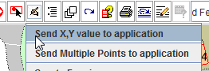

You will be asked to confirm your selection, once confirmed the appropriate co-ordinates will be returned to the form.

For more information on the spatial enablement of documents see Figure 25

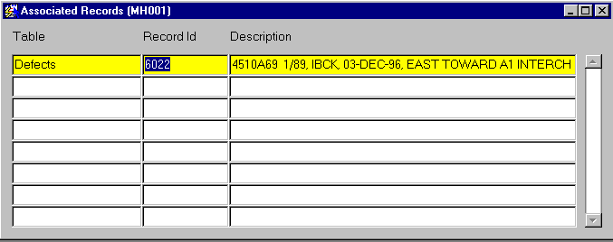Figure 23

Documents:

Associated Records

Associated Records Button

This window is used to associate and view documents with database records stored within the ***Exor*** database. Documents or images may also be associated with records using the Document Manager interface on any form within ***Exor***, which has access to the ***Document Manager*** facility (refer to the Document Manager User Guide).

When you enter this window any previously associated records will be display. To associate another record to the document press [***Create Record***] or press [***F6***].

Table (Required) (List)

Enter the table the associated record is held within. The information available in the Table field will have been supplied as meta data and would have been previously entered using ***Document Gateways - DOC0130*** (page 23).

Record ID (Required) (List)

Enter the record that the document is to be associated with. The Table selected in the previous field will determine the List of Values

Description (Display Only)

The record Description will be displayed.

Figure 24

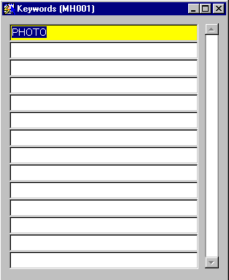Documents: Keywords

Keywords Button

This window is used to associate keywords to documents. A document may have more than one keyword.

When you enter this window any previously associated keywords will be displayed. To add another keyword, press [**Create Record**] or press [**F6**].

Keyword (Required) (List)

Enter the keyword to be associated with the document. These will have already been set up using ***Keywords - DOC0116.***

Spatial Enablement of Documents

For a document record in ***Documents - DOC0100***, you can assign a pair of coordinates and create a spatial representation to display in the map.

You need to register a Document Layer to start with using the ***GIS Layer tool - GIS0020*** to achieve this, along with configuring Mapviewer/Exor locator to display it.

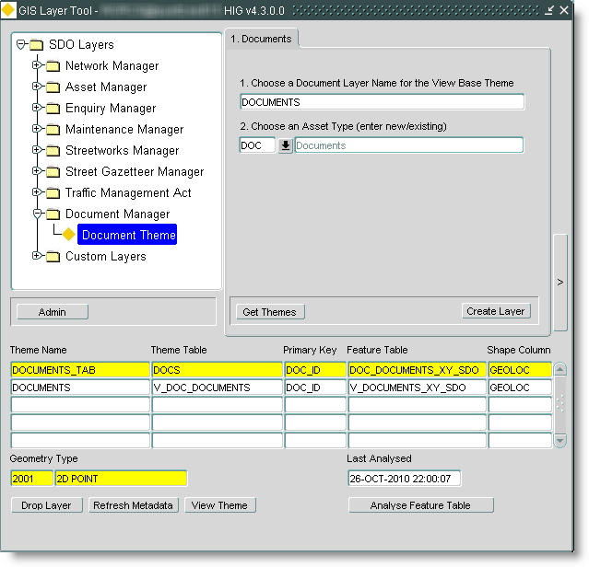Figure 25

Register Document

Layer

Once the associations have been made the standard show map icon  can then be used to call locator from the Documents module, this will then zoom to the document icon on the map.

With the document icon selected the user may use the select to option to select:

* **Edit Document**, this will call Documents – DOC0100 where the attributed may be edited
* **Display Document**, this will display the document.

Circulation by Person - DOC0114

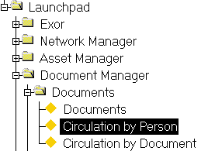Figure 26

Circ by Person

Menu Option

This form is used to keep a track of documents through an organization and to monitor who has responsibility for a given document at a given point in time.

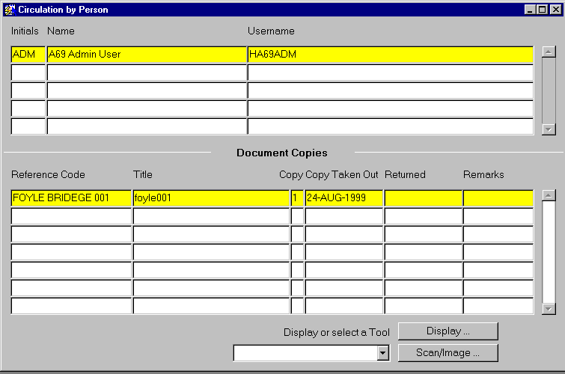Figure 27

Circulation by person

Circulation by Person

When you enter this form all current users details will be displayed. To select the appropriate person press [**Enter Query**] or press [**F7**] enter the selection criteria then press [**Execute Query**] or press [**F8**].

Initials (Required) (List)

Enter the initials of the person required.

Name (Display Only)

The person's name will be displayed

Username (Display Only)

The person's username will be displayed.

Note that you may also use either the Name or User Name fields to retrieve the required person's details.

Document Copies

When you enter this block, the cursor sits in the Reference Code field waiting for you to enter details of the document that the person is to take out.

Reference Code (Required) (List)

Enter the reference code of the document.

Title (Display Only)

The title of the selected document will be displayed.

Copy (Display Only)

The system will generate the copy number of this document i.e. the number of times it has been taken out.

Date Taken Out (Required, Default)

Enter the date the document was taken out. The default is today's date, but this may be changed if required.

Note that once the record is saved the Date Taken Out cannot be changed.

Date Returned (Optional)

Enter the date the document was returned.

Remarks (Optional) (Edit)

Enter any comments that are required for this copy of the document.

Display

This button allows you to display the image or document using the PC resident tool specified in the Display Command field in ***Media Types - DOC0118*** (page 7).

To display the document or image, press the [**Display**] button. This will start the viewer application and open the document file.

Scan/Image…

This button allows you to scan an image or use any of the 5 image commands specified in ***Media Types - DOC0118*** (page 7).

To select the Scan command or any of the other 5 image commands

1. Click on the arrow in the Display or select a Tool window.

This will display any scan or image commands specified in ***Media Types - DOC0118.***

1. Click on the desired command.
2. Press the [**Scan/Image…**] button.

Circulation by Document - DOC0115

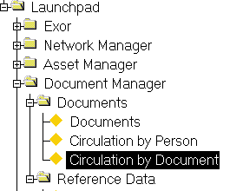Figure 28

Circ by Document

This form is used to keep a track of documents through an organization and to monitor who has responsibility for a given document at a given point in time.

Figure 29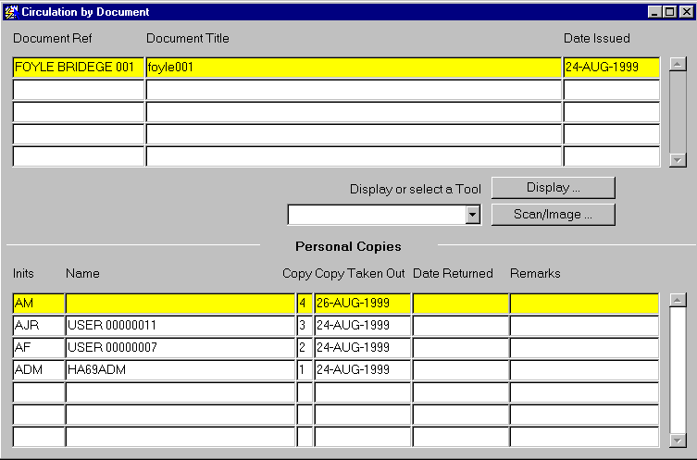

Circulation by Document

Circulation by Document

When you enter this form all Document References will be displayed. To select the appropriate Document press [**Enter Query**] or press [**F7**] enter the selection criteria then press [**Execute Query**] or press [**F8**].

Document Ref (Required) (List)

Enter the document reference code required.

Document Title (Display Only)

The document title will be displayed

Date Issued (Display Only)

The date the document was issued will be displayed.

Note that you may also use either the 'Document Title' or 'Date Issued' fields to retrieve the required document.

Personal Copies

When you enter this window, the cursor sits in the 'Inits' field waiting for you to enter details of the person that is taking out the document.

Inits (Required) (List)

Select the initials of the person who has a copy of the current document.

Name (Display Only)

The name of the selected person will be displayed

Copy (Display Only)

The system will generate the copy number of this document i.e. the number of times it has been taken out.

Date Taken Out (Required, Default)

Enter the date the document was taken out. The default is today's date, but this may be changed if required.

Note that once the record is saved the 'Date Taken Out' cannot be changed.

Date Returned (Optional)

Enter the date the document was returned.

Remarks (Optional) (Edit)

Enter any comments that are required for this copy of the document.

Display

This button allows you to display the image or document using the PC resident tool specified in the Display Command field in ***Media Types - DOC0118***

To display the document or image, press the [**Display**] button. This will start the viewer application and open the document file.

Scan/Image…

This button allows you to scan an image or use any of the 5 image commands specified in ***Media Types - DOC0118.***

To select the Scan command or any of the other 5 image commands

1. Click on the arrow in the Display or select a Tool window.

This will display any scan or image commands specified in ***Media Types - DOC0118.***

1. Click on the desired command.
2. Press the [**Scan/Image…**] button.

Bulk Document Loader – Document Bundles

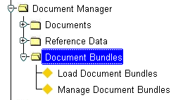Figure 30

Document

Bundles

Menu

The Bulk Document Loader can be used in two ways:

* Manually load ‘bundles’ of documents using the ***Load Document Bundles – DOC0300*** or ***Submit a Process – HIG2510***
* Use the Automated Process Framework to automatically load ‘bundles’ of documents

A Load Document Bundle process Type is shipped with Document Manager, this process supports polling of an ftp directory.

Note. If this is to be used some configuration will need to take place:

See the Exor Admin Guide for details on setting ***Process Types – HIG2500*** variables, this following setup will need to be considered

1. Additional Process Type Roles and Frequencies can be set
2. If wishing to poll; the FTP Connection Type must be set
3. If wishing to poll by area; the polling areas must be defined in the ‘Polling Locations’ tab
4. The Oracle Directory from which document bundles are to be loaded must be defined in the ‘Process Locations’ tab

The bulk Document Loader will load a bundle of documents such as photographs and associates them with the appropriate business feature such as an asset or defect.

For example, a series of ‘after photos’ may be required once the defects have been repaired, thise defects will exist within the system and will need the documents associating with them retrospectively.

The Bulk Document Loader uses a ‘driving file’ that contains a list of documents, their document type and the Id of the associated business feature. The actual documents, e.g. photographs, are contained within a zip file.

If the load fails, a discard file is produced that contains the erroneous documents with an error so they can be corrected and re-loaded.

The loader also ensures the loaded documents have a unique reference by prefixing a unique id to the original document Id

Document Bundles

The Bulk Document Loader is driven by document bundles, a document bundle is a zip file containing two sets of data:

1. Source files of the documents (e.g. .doc, .jpg, .pdf) that we need to reference from within Document Manager
2. A ‘Driving File’ which lists all of the documents in 1. and which gives sufficient information for each file in order to reference it in Document Manager

Driving File

The format of the driving file is as follows:

|  |  |  |  |  |  |
| --- | --- | --- | --- | --- | --- |
| **Attribute**  **Seq** | **Name** | **Format** | **Upper**  **Case** | **Mandatory** | **Notes** |
| 1 | doc_file | VARCHAR(240) |  | ✓ | Pointer at a file supplied within the bundle |
| 2 | doc_title | VARCHAR2(60) |  | ✓ | Attribute of the DOCS record that is to be created |
| 3 | doc_descr | VARCHAR2(2000) |  |  | Attribute of the DOCS record that is to be created |
| 4 | doc_type | VARCHAR2(4) | ✓ | ✓ | Attribute of the DOCS record that is to be created  **Must match an entry in DOC_TYPES table (DOC_TYPES.DTP_CODE)** |
| 5 | doc_location_name | VARCHAR2(30) | ✓ | ✓ | In order for the loader to determine where the file is ultimately moved to  **Much match an entry in DOC_LOCATIONS table (DOC_LOCATIONS.DLC_NAME)** |
| 6 | gateway_table_name | VARCHAR2(30) | ✓ |  | The scope of this isn’t limited to associations to a defect, hence the need for this attribute which identifies the gateway table for the document association to be created  Much match an entry in DOC_GATEWAYS table (DOC_GATEWAYS.DGT_TABLE_NAME) |
| 7 | rec_id | VARCHAR2(30) |  |  | The foreign key pointing to the record within the table named by the ‘gateway table name’ attribute. |
| 8 | x_coordinate | NUMBER |  |  | The x coordinate for the document |
| 9 | y_coordinate | NUMBER |  |  | The y coordinate for the document |

A driving file has some special characteristics, these are as follows:

* All values must be comma separated
* All values must be encapsulated with “ ”
* Driving files may be in the document bundle and are distinguished from documents within the bundle by virtue of a *.driving* extension e.g. *list_of_docs.driving*

An extract from a sample driving file is as follows:

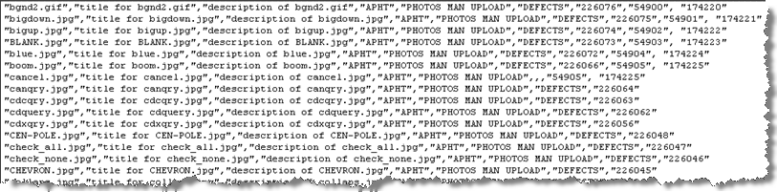

Figure 31

Driving

File

Loader Failure

The loader will raise a failure under the following circumstances

* The file identified in the doc_file attribute is not supplied as a file within the bundle
* A file supplied in the bundle is not referenced within a driving file within the bundle
* doc_type does not correspond to an entry in DOC_TYPES table
* doc_location_name does not correspond to an entry in DOC_LOCATIONS table
* gateway_table_name is supplied and does not correspond to an entry in DOC_GATEWAYS
* gateway_table_name and rec_id is supplied and does not identify a record in the table named in the gateway_table_name attribute
* neither (gateway_table_name and rec_id) OR (x_coordinate and y_coordinate) are supplied. Note that all four attributes can be supplied

If the loader fails the user can use ***Manage Document Bundles – DOC0310*** to view the issues with the load, create a discard file and re-run the load with those files that failed the initial load.

Document Bundle File

The document bundle file has specific characteristics, these are as follows:

* The document bundle must be a .zip file
* Only files created via Winzip or Windows own compression tool will work
* Unzipping of the zip files has only been proven when implemented against a database hosted on a Linux or Windows box
* Software to unzip files must reside on box which hosts the database
* The zip file will not extract to a directory hierarchy, i.e. the driving file(s) and the documents are all stored at the one level
* A document bundle may contain one or more driving files
* A ‘doc_file’ within a document bundle can be referenced more than once in a driving file(s) e.g. should you wish a document to be attributed to more than one item.
* When the loader moves the ‘doc_file’ to the correct document location, they are renamed to make the filename unique. To achieve this the document id is prefixed to the filename e.g. “boom.jpg” could become “32456_boom.jpg”
* To ensure uniqueness of Document Bundle filenames it is suggested that a file naming convention is adopted by customers

A possible file naming convention for document bundle files is: <username>_<date>_<time>.zip

Where:

<username> - username of the exor user to which to bundle is attributed.

<date> - date of file YYYYMMDD

<time> - time of file HH24MISS

e.g. HIGHWAYS_20100422_092245.zip

An example document bundle zip file containing a number of documents and a driving file is shown below:

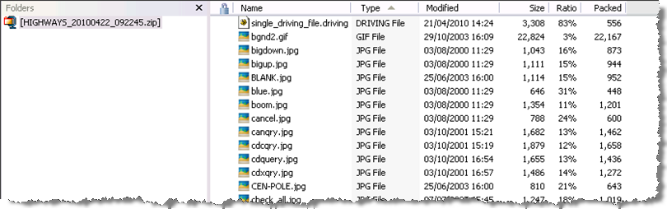Figure 32

**Document**

**Bundle**

Manage Document Bundles – DOC0310

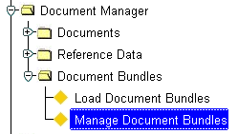Figure 33

Manage Document

Bundles Menu

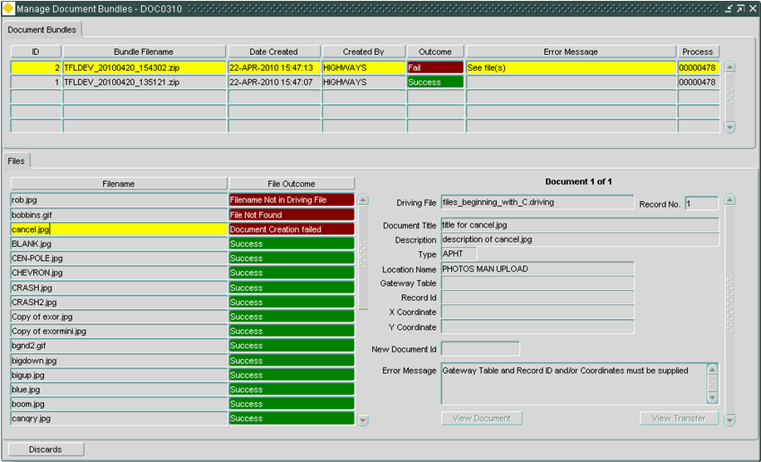Figure 34

**Manage Document**

**Bundles**

Manage Document Bundles

As the bulk document loader loads data it populates a number of tables with data, this module allows the user to view the data in those tables.

This module can be invoked both from the Launchpad or by selecting the [More details] button in the ***Process Monitor – HIG2520*** and the ***Process Execution Log – HIG2540***

This screen is read only for viewing bundle related data, in addition it has the following buttons:

**[View Document]** will call ***Documents - DOC0100*** to view a document which has been created as a result of processing an entry in a driving file

**[View transfer]** will call ***Transfer Log – HIG2600*** which shows information relating to the transfer of the “document file” to the appropriate document location

**[Discards]** This will take the user to a directory containing all the failed files plus a new driving file with all the failed records for the bundle, this allows re-submission of the failed files.

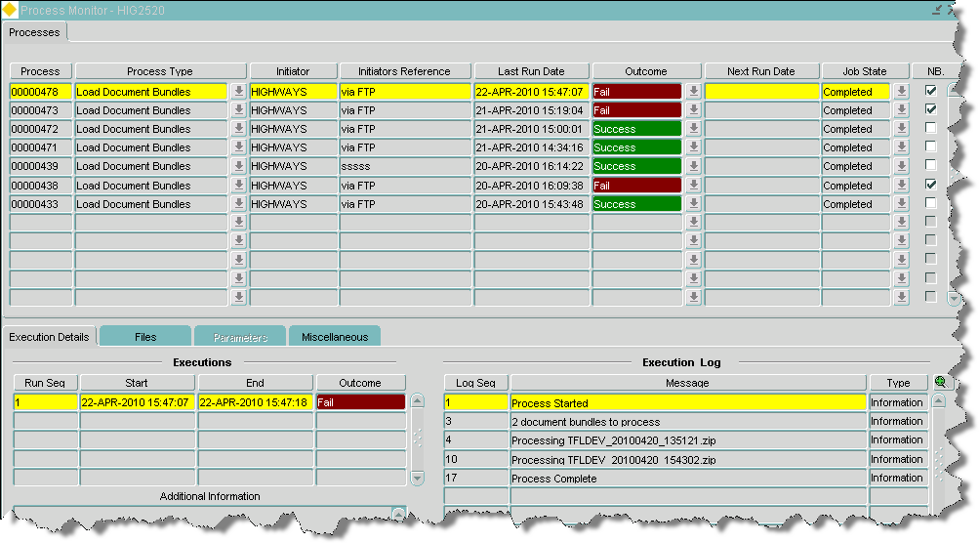Figure 35

**Document Bundles**

**Process Monitor**

Manage Document Bundles – Process Monitor

The standard process framework functionality allows the monitoring of Load Document Bundle processes.

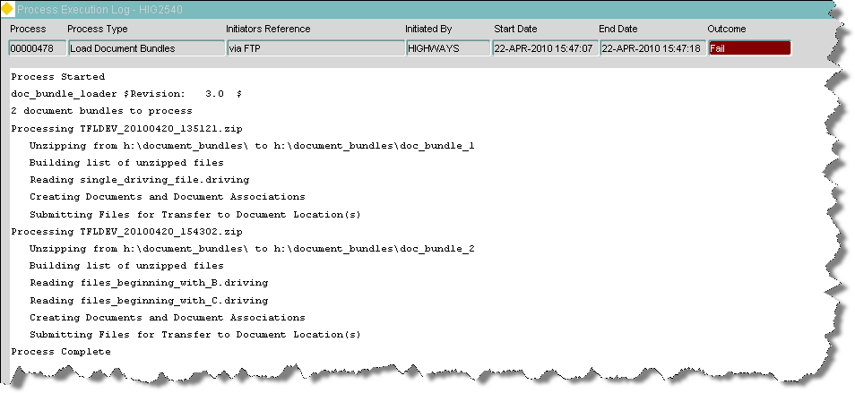Figure 36

Document Bundles

Process Execution

Log

Manage Document Bundles – Process Execution Log

The Process execution log will show a log of the document bundle load with any errors the system may have encountered.

Index

Associated Records 27

Circulation by Document 4, 32, 35, 38, 39

Circulation by Person 4, 30

Document Copies 31

Document Gateways 3, 23, 27

Document Types 3, 18, 19, 22, 26

Documents 3, 6, 18, 19, 24, 26, 27, 28

**ENQCAT** 18

**ENQCLASS** 18

**ENQDEFENQT** 18

**ENQSTODEF** 18

Enquiry Category 18, 20, 21

Enquiry Class 18, 21, 22

Enquiry Types 3, 18, 19, 21, 22

***Enquiry/Treatment types*** 18

ENQWLFCLAS 21

Locations 10, 12

Media Types 3, 7, 25, 31, 33

Media/Locations 7

Prerequisites 6